What is the hub?

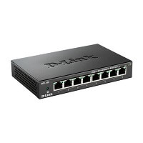

A hub is a common connection point, also known as a network hub, which is used for connection of devices in a network. It works as a central connection for all the devices that are connected through a hub. The hub has numerous ports. If a packet reaches at one port, it is able to see by all the segments of the network due to a packet is copied to the other ports. A network hub has no routing tables or intelligence (unlike a network switch or router), which is used to send information and broadcast all network data across each and every connection.

Although most of the hubs can recognize network troubles or errors like collisions, broadcasting all information to the several ports can be a security risk and cause bottlenecks. The network hubs were popular in the past time as they were cheaper as compared to a switch or router. Nowadays, switches are much cheaper than a hub and provide a better solution for any network. Furthermore, a hub is no [IP](https://www.javatpoint.com/ip)

address, as it is a dumb device.

Types of Hub

There are three types of the hub that are given below:

1. Passive Hub
2. Active Hub
3. Intelligent Hub

**Passive Hub:** The passive hubs are the connection point for wires that helps to make the physical network. It is capable of determining the bugs and faulty hardware. Simply, it accepts the packet over a port and circulates it to all ports. It includes connectors (10base-2 port and RJ-45) that can be applied as a standard in your network. This connector is connected to all [local area network (LAN)](https://www.javatpoint.com/wireless-lan-introduction)

devices. Additionally, the advanced passive hubs have AUI ports, which are connected as the transceiver according to the network design.

Keep Watching

**Active Hub:** As compared to a passive hub, it includes some additional features. It is able to monitor the data sent to the connected devices. It plays an important role between the connected devices with the help of store technology, where it checks the data to be sent and decides which packet to send first.

It has the ability to fix the damaged packets when packets are sending, and also able to hold the direction of the rest of the packets and distribute them. If a port receives a weak signal, but still it is readable, then the active hub reconstructs the weak signal into a stronger signal before its sending to other ports. It can boost the signal if any connecting device is not working in the network. Therefore, it helps to make the continuity of services in LAN.

**Intelligent Hub:** It is a little smarter than passive and active hubs. These hubs have some kinds of management software that help to analyze the problem in the network and resolve them. It is beneficial to expend the business in networking; the management can assign users that help to work more quickly and share a common pool efficiently by using intelligent hubs. However, it offers better performance for the local area network. Furthermore, with any physical device, if any problem is detected, it is able to detect this problem easily.

Features of Hub

* It acts with shared bandwidth and broadcasting.
* It includes only one collision domain and broadcast domain.
* It works at the physical layer of the OSI model and also offers support for half-duplex transmission mode.
* It cannot create a virtual LAN and does not support spanning tree protocol.
* Furthermore, mainly packet collisions occur inside the hub.
* It also has a feature of flexibility, which means it includes a high transmission rate to different devices.

Applications of Hub

The important applications of a hub are given below:

* Hub is used to create small home networks.
* It is used for network monitoring.
* They are also used in organizations to provide connectivity.
* It can be used to create a device that is available thought out of the network.

What hubs do?

Hubs work as a central connection between all network equipment and handle a data type, which is called frames. If a frame is received, it is transmitted to the port of the destination computer after amplifying it. A frame is passed to each of its ports in the hub, whether it is destined only for one port. It does not include the way of deciding a frame to which port it should be sent. Therefore, a frame has to transmit to every port, which ensures that it will reach its intended destination that generates a lot of traffic on the network and can be caused to damage the network. The hub is slower as compared to standard switch as it is not able to send or receive information at the same time, but a switch is more costly than a hub.

Advantages of Hub

* It provides support for different types of Network Media.
* It can be used by anyone as it is very cheap.
* It can easily connect many different media types.
* The use of a hub does not impact on the network performance.
* Additionally, it can expand the total distance of the network.

Disadvantages of Hub

* It has no ability to choose the best path of the network.
* It does not include mechanisms such as collision detection.
* It does not operate in full-duplex mode and cannot be divided into the Segment.
* It cannot reduce the network traffic as it has no mechanism.
* It is not able to filter the information as it transmits packets to all the connected segments.
* Furthermore, it is not capable of connecting various network architectures like a ring, token, and ethernet, and more.

# What are Routers in Computer Network?

[Computer Network](https://www.tutorialspoint.com/questions/category/Computer-Network" \t "_blank)[ComputerEngineering](https://www.tutorialspoint.com/questions/category/Computer-Engineering" \t "_blank)[MCA](https://www.tutorialspoint.com/questions/category/MCA" \t "_blank)

Routers are networking devices operating at layer 3 or a network layer of the OSI model. They are responsible for receiving, analysing, and forwarding data packets among the connected computer networks. When a data packet arrives, the router inspects the destination address, consults its routing tables to decide the optimal route and then transfers the packet along this route.

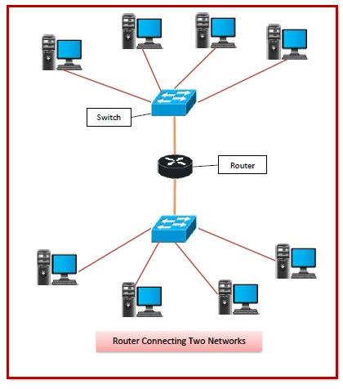

## Features of Routers

* A router is a layer 3 or network layer device.
* It connects different networks together and sends data packets from one network to another.
* A router can be used both in LANs (Local Area Networks) and WANs (Wide Area Networks).
* It transfers data in the form of IP packets. In order to transmit data, it uses IP address mentioned in the destination field of the IP packet.
* Routers have a routing table in it that is refreshed periodically according to the changes in the network. In order to transmit data packets, it consults the table and uses a routing protocol.
* In order to prepare or refresh the routing table, routers share information among each other.
* Routers provide protection against broadcast storms.
* Routers are more expensive than other networking devices like hubs,bridges and switches.
* Routers are manufactured by some popular companies like −
  + Cisco
  + D-Link
  + HP
  + 3Com
  + Juniper
  + Nortel

## Routing Table

The functioning of a router depends largely upon the routing table stored in it. The routing table stores the available routes for all destinations. The router consults the routing table to determine the optimal route through which the data packets can be sent.

A routing table typically contains the following entities −

* IP addresses and subnet mask of the nodes in the network
* IP addresses of the routers in the network
* Interface information among the network devices and channels

Routing tables are of two types −

* **Static Routing Table** − Here, the routes are fed manually and are not refreshed automatically. It is suitable for small networks containing 2-3 routers.
* **Dynamic Routing Table** − Here, the router communicates with other routers using routing protocols to determine the available routes. It is suited for larger networks having large number of routers.

## Types of Routers

A variety of routers are available depending upon their usages. The main types of routers are −

* **Wireless Router** − They provide WiFi connection WiFi devices like laptops, smartphones etc. They can also provide standard Ethernet routing. For indoor connections, the range is 150 feet while its 300 feet for outdoor connections.
* **Broadband Routers** − They are used to connect to the Internet through telephone and to use voice over Internet Protocol (VoIP) technology for providing high-speed Internet access. They are configured and provided by the Internet Service Provider (ISP).
* **Core Routers** − They can route data packets within a given network, but cannot route the packets between the networks. They helps to link all devices within a network thus forming the backbone of network. It is used by ISP and communication interfaces.
* **Edge Routers** − They are low-capacity routers placed at the periphery of the networks. They connect the internal network to the external networks, and are suitable for transferring data packets across networks
* **Brouters** − Brouters are specialised routers that can provide the functionalities of bridges as well. Like a bridge, brouters help to transfer data between networks. And like a router, they route the data within the devices of a network.

A gateway is a network node that forms a passage between two networks operating with different transmission protocols. The most common type of gateways, the network gateway operates at layer 3, i.e. network layer of the OSI (open systems interconnection) model. However, depending upon the functionality, a gateway can operate at any of the seven layers of OSI model. It acts as the entry – exit point for a network since all traffic that flows across the networks should pass through the gateway. Only the internal traffic between the nodes of a LAN does not pass through the gateway.

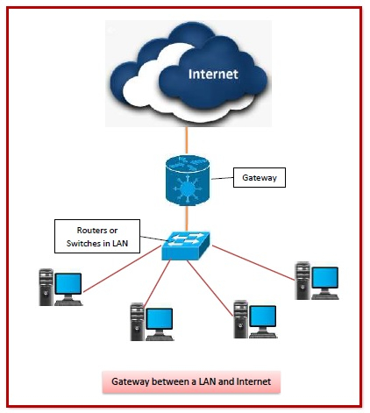

## Features of Gateways

* Gateway is located at the boundary of a network and manages all data that inflows or outflows from that network.
* It forms a passage between two different networks operating with different transmission protocols.
* A gateway operates as a protocol converter, providing compatibility between the different protocols used in the two different networks.
* The feature that differentiates a gateway from other network devices is that it can operate at any layer of the OSI model.
* It also stores information about the routing paths of the communicating networks.
* When used in enterprise scenario, a gateway node may be supplemented as proxy server or firewall.
* A gateway is generally implemented as a node with multiple NICs (network interface cards) connected to different networks. However, it can also be configured using software.
* It uses packet switching technique to transmit data across the networks.

## Types of Gateways

On basis of direction of data flow, gateways are broadly divided into two categories −

* **Unidirectional Gateways** − They allow data to flow in only one direction. Changes made in the source node are replicated in the destination node, but not vice versa. They can be used as archiving tools.
* **Bidirectional Gateways** − They allow data to flow in both directions. They can be used as synchronization tools.

Repeaters are network devices operating at physical layer of the OSI model that amplify or regenerate an incoming signal before retransmitting it. They are incorporated in networks to expand its coverage area. They are also known as signal boosters.

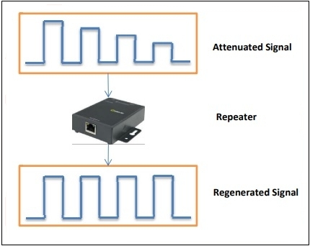

**Why are Repeaters needed?**

When an electrical signal is transmitted via a channel, it gets attenuated depending upon the nature of the channel or the technology. This poses a limitation upon the length of the LAN or coverage area of cellular networks. This problem is alleviated by installing repeaters at certain intervals.

Repeaters amplifies the attenuated signal and then retransmits it. Digital repeaters can even reconstruct signals distorted by transmission loss.So, repeaters are popularly incorporated to connect between two LANs thus forming a large single LAN. This is shown in the following diagram −

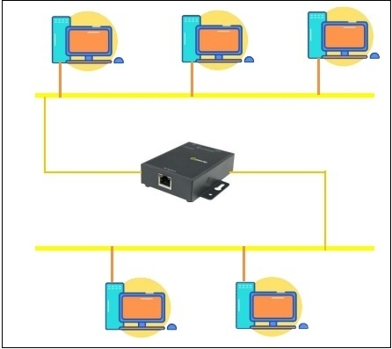

**Types of Repeaters**

According to the types of signals that they regenerate, repeaters can be classified into two categories −

* **Analog Repeaters** − They can only amplify the analog signal.
* **Digital Repeaters** − They can reconstruct a distorted signal.

According to the types of networks that they connect, repeaters can be categorized into two types −

* **Wired Repeaters** − They are used in wired LANs.
* **Wireless Repeaters** − They are used in wireless LANs and cellular networks.

According to the domain of LANs they connect, repeaters can be divided into two categories −

* **Local Repeaters** − They connect LAN segments separated by small distance.
* **Remote Repeaters** − They connect LANs that are far from each other.

**Advantages of Repeaters**

* Repeaters are simple to install and can easily extend the length or the coverage area of networks.
* They are cost effective.
* Repeaters don’t require any processing overhead. The only time they need to be investigated is in case of degradation of performance.
* They can connect signals using different types of cables.

**Disadvantages of Repeaters**

* Repeaters cannot connect dissimilar networks.
* They cannot differentiate between actual signal and noise.
* They cannot reduce network traffic or congestion.
* Most networks have limitations upon the number of repeaters that can be deployed.

Switches are networking devices operating at layer 2 or a data link layer of the OSI model. They connect devices in a network and use packet switching to send, receive or forward data packets or data frames over the network.

A switch has many ports, to which computers are plugged in. When a data frame arrives at any port of a network switch, it examines the destination address, performs necessary checks and sends the frame to the corresponding device(s).It supports unicast, multicast as well as broadcast communications.

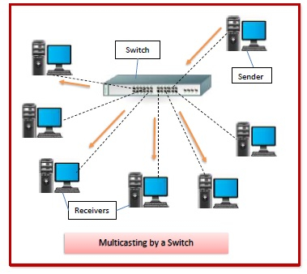

## Features of Switches

* A switch operates in the layer 2, i.e. data link layer of the OSI model.
* It is an intelligent network device that can be conceived as a multiport network bridge.
* It uses MAC addresses (addresses of medium access control sublayer) to send data packets to selected destination ports.
* It uses packet switching technique to receive and forward data packets from the source to the destination device.
* It is supports unicast (one-to-one), multicast (one-to-many) and broadcast (one-to-all) communications.
* Transmission mode is full duplex, i.e. communication in the channel occurs in both the directions at the same time. Due to this, collisions do not occur.
* Switches are active devices, equipped with network software and network management capabilities.
* Switches can perform some error checking before forwarding data to the destined port.
* The number of ports is higher – 24/48.

## Types of Switches

There are variety of switches that can be broadly categorised into 4 types −

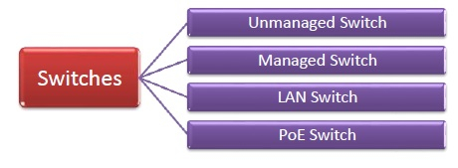

* **Unmanaged Switch** − These are inexpensive switches commonly used in home networks and small businesses. They can be set up by simply plugging in to the network, after which they instantly start operating. When more devices needs to be added, more switches are simply added by this plug and play method. They are referred to as u managed since they do not require to be configured or monitored.
* **Managed Switch** − These are costly switches that are used in organisations with large and complex networks, since they can be customized to augment the functionalities of a standard switch. The augmented features may be QoS (Quality of Service) like higher security levels, better precision control and complete network management. Despite their cost, they are preferred in growing organizations due to their scalability and flexibility. Simple Network Management Protocol (SNMP) is used for configuring managed switches.
* **LAN Switch** − Local Area Network (LAN) switches connects devices in the internal LAN of an organization. They are also referred as Ethernet switches or data switches. These switches are particularly helpful in reducing network congestion or bottlenecks. They allocate bandwidth in a manner so that there is no overlapping of data packets in a network.
* **PoE Switch** − Power over Ethernet (PoE) switches are used in PoE Gogabit Ethernets. PoE technology combine data and power transmission over the same cable so that devices connected to it can receive both electricity as well as data over the same line. PoE switches offer greater flexibility and simplifies the cabling connections

A bridge is a network device that connects multiple LANs (local area networks) together to form a larger LAN. The process of aggregating networks is called network bridging. A bridge connects the different components so that they appear as parts of a single network. Bridges operate at the data link layer of the OSI model and hence also referred as Layer 2 switches.

The following diagram shows a bridges connecting two LANs −

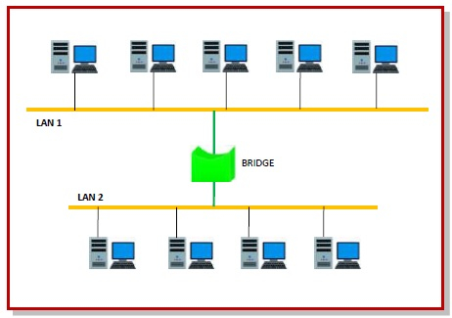

**Uses of Bridge**

* Bridges connects two or more different LANs that has a similar protocol and provides communication between the devices (nodes) in them.
* By joining multiple LANs, bridges help in multiplying the network capacity of a single LAN.
* Since they operate at data link layer, they transmit data as data frames. On receiving a data frame, the bridge consults a database to decide whether to pass, transmit or discard the frame.
  + If the frame has a destination MAC (media access control) address in the same network, the bridge passes the frame to that node and then discards it.
  + If the frame has a destination MAC address in a connected network, it will forward the frame toward it.
* By deciding whether to forward or discard a frame, it prevents a single faulty node from bringing down the entire network.
* In cases where the destination MAC address is not available, bridges can broadcast data frames to each node. To discover new segments, they maintain the MAC address table.
* In order to provide full functional support, bridges ideally need to be transparent. No major hardware, software or architectural changes should be required for their installation.
* Bridges can switch any kind of packets, be it IP packets or AppleTalk packets, from the network layer above. This is because bridges do not examine the payload field of the data frame that arrives, but simply looks at the MAC address for switching.
* Bridges also connect virtual LANs (VLANs) to make a larger VLAN.
* A wireless bridge is used to connect wireless networks or networks having a wireless segment

**History of Modems**

The first devices called modems converted digital data for transmission over analog telephone lines. The speed of these modems was measured in baud (a unit of measurement named after Emile Baudot), although as computer technology developed, these measures were converted into [bits per second](https://www.lifewire.com/bits-per-second-kbps-mbps-gbps-818122). The first commercial modems supported a speed of 110 bps and were used by the U.S. Department of Defense, news services, and some large businesses.

Modems gradually became familiar to consumers in the late 1970s through the 1980s as public message boards and news services like CompuServe were built on early internet infrastructure. Then, with the explosion of the World Wide Web in the mid and late 1990s, dial-up modems emerged as the primary form of internet access in many households around the world.

**Dial-Up Modems**

Modems used on [dial-up networks](https://www.lifewire.com/definition-of-dial-up-817779) convert data between the analog form used on telephone lines and the digital form used on computers. An external dial-up modem plugs into a computer at one end and a telephone line on the other end. In the past, some computer makers integrated internal dial-up modems into the computer.

Modern dial-up network modems transmit data at a maximum rate of 56,000 bits per second. However, the inherent limitations of public telephone networks often limit modem data rates to 33.6 Kbps or lower.

**Broadband Modems**

A [broadband modem](https://www.lifewire.com/definition-of-broadband-modem-817451) like those used for DSL or cable internet access uses advanced signaling techniques to achieve dramatically higher network speeds than earlier-generation dial-up modems. [Broadband modems](https://www.lifewire.com/what-is-an-ethernet-card-817547) are often referred to as *high-speed modems*. [Cellular modems](https://www.lifewire.com/networking-cell-phones-and-wireless-modems-817461) are a type of digital modem that establishes internet connectivity between a mobile device and a [cell phone network](https://www.lifewire.com/how-fast-is-a-cell-phone-modem-818317).

**Modem is abbreviation for Modulator – De-modulator.**Modems are used for data transfer from one [computer](https://ecomputernotes.com/fundamental/introduction-to-computer/what-is-computer) network to another [computer](https://ecomputernotes.com/fundamental/introduction-to-computer/what-is-computer) network through telephone lines. The computer network works in digital mode, while analog technology is used for carrying massages across phone lines.

**Modulator** converts [information](https://ecomputernotes.com/fundamental/information-technology/what-do-you-mean-by-data-and-information) from **digital mode to analog mode** at the transmitting end and de-modulator converts the same from **analog to digital at receiving end**. The process of converting [analog signals](https://ecomputernotes.com/computernetworkingnotes/communication-networks/analog-signal) of one computer network into digital signals of another computer network so they can be processed by a receiving computer is **referred to as digitizing.**

When an analog facility is used for data communication between two digital devices called Data Terminal Equipment (DTE), modems are used at each end. DTE can be a terminal or a computer.

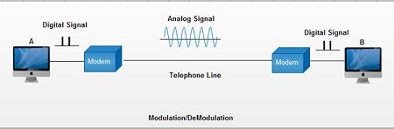

The modem at the transmitting end converts the digital signal generated by DTE into an analog signal by modulating a carrier. This modem at the receiving end demodulates the carrier and hand over the demodulated digital signal to the DTE.

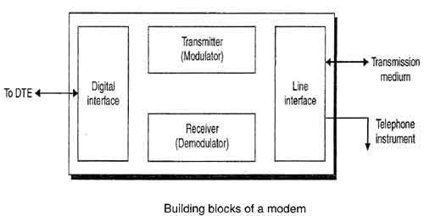

The transmission medium between the two modems can be dedicated circuit or a switched telephone circuit. If a switched telephone circuit is used, then the modems are connected to the local telephone exchanges. Whenever data transmission is required connection between the modems is established through telephone exchanges.

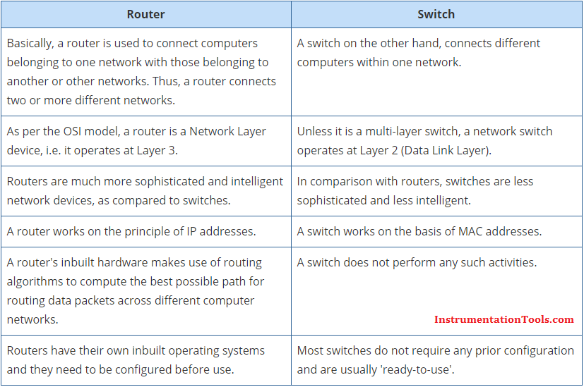

|  |  |
| --- | --- |
| **Routers** | **Bridges** |
| Routers operate in the network layer of [OSI Model](https://www.learnabhi.com/osi-model-computer-network/). | Bridge operates in data link layer of OSI Model. |
| The router is used to connect the [LAN and WAN](https://www.learnabhi.com/difference-between-lan-can-man-and-wan/). | The bridge is used to connect two different LAN segments. |
| The router transmits data in the form of packets. | Bridge transmit data in the form frames. |
| It reads the [IP Address](https://www.learnabhi.com/ip-address/) of a device. | Bridge reads the [MAC Address](http://searchnetworking.techtarget.com/definition/MAC-address) of a device. |
| The router has more ports compare to bridge. | The bridge has only two ports. |
| It uses routing table for sending data. | The bridge does not use any routing table for sending data. |
| It works on more than one broadcast domain. | It works on a single broadcast domain. |
| Routers use a software-configured network address to determine the address. | Bridges determine the destination address with the help of the MAC address of the device. |
| It communicates with other routers to decide the best way to transfer the data. | With the help of MAC addresses of the devices, the Bridges listen to the network traffic and then decide the way to send the data. |
| The router creates multiple paths to send data. | The bridge does not create multiple paths to send data. |
| You can configure [protocols](https://www.learnabhi.com/tcp-ip-protocol-port-number/) such as RIP, IGRP, OSPF, etc in a router. | You cannot configures any routing protocols in a bridge. |

